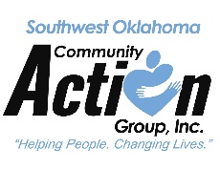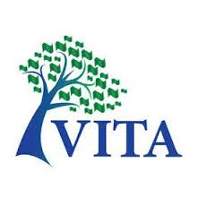

F**ree** Tax

Preparation

Volunteer Income

Tax Assistance

What to bring checklist:

* Photo ID (taxpayer & spouse)
* Social Security cards for taxpayer & all dependents or ITIN
* Birthdates for all dependents
* W2’s for wages
* 1099R pension income if retired
* 1095A Health Insurance for Affordable Care Act
* 1099’s for interest or other payments received
* SSA 1099 for Social Security income
* Last year’s tax returns
* Total amount paid in daycare
* Daycare providers tax identification number
* Bank routing and account numbers for direct deposit
* **IRS letter 6419 - Advanced Child Tax credit payment**
* **IRS letter 6475 - EIP (stimulus) payment.**

**AmeriCorps Seniors serving with Southwest Oklahoma Community Action Group, Inc.’s RSVP (Retired and Senior Volunteer Program) in Volunteer Income Tax Assistance (VITA)**

If you are a low-to-moderate income **($58,000 or less)** taxpayer, trained volunteers prepare tax returns at the following Greer, Harmon, and Jackson County VITA sites:

**ALTUS Senior Center**

221 N. Park Lane, Altus, OK

**Open Tuesdays & Thursdays 11:00 a.m. – 6:00 p.m.**

**Start Date: Jan 25, 2022, End Date: Apr 14, 2022**

**No appointments necessary.**

**HOLLIS – Hollis Sr. Meal Site**

901 E. Vivian, Hollis, OK **1st Wednesday of Month**

**(Feb 2; Mar 2; Apr 6) 9:30 a.m. - 1:00 p.m.**

*Appointments only call Hollis Head Start (580)688-9177*

**Form 538S $40 Sales Tax Relief ONLY does not require an appointment.**

**MANGUM – First United Methodist Church**

301 W. Jefferson, Mangum, OK

**Every Other Wednesday (Except April 7) 8:30 a.m. - 2:00 p.m.**

**Start Date: Jan 26, 2022 End Date: Apr 13, 2022**

*Appointments only call Mangum Head Start (580)782-3712*

**Form 538S $40 Sales Tax Relief ONLY does not require an appointment.**

**Facemasks are required and CDC recommendations will be in**

**place. Please find someone to care for your children. There**

**will be limited entry to the site. Your patience is appreciated.**

Volunteer Income

Tax Assistance



**Weather policy:**  In the event of an inclement weather closure, Southwest Oklahoma Community Action Group will post information on our Facebook page.

**Please Note:** We have uniquely listed dates and times for each location. The number of individuals served will be based on how many volunteers are available to prepare taxes.

**Scope:** Some tax returns are not within the scope of VITA.

**For More information, please call AmeriCorps Seniors RSVP at (580) 482-4141.**